**RStudio IDE** RStudio is the GUI for all things R. When you first open RStudio, typically you will see four separate panels.

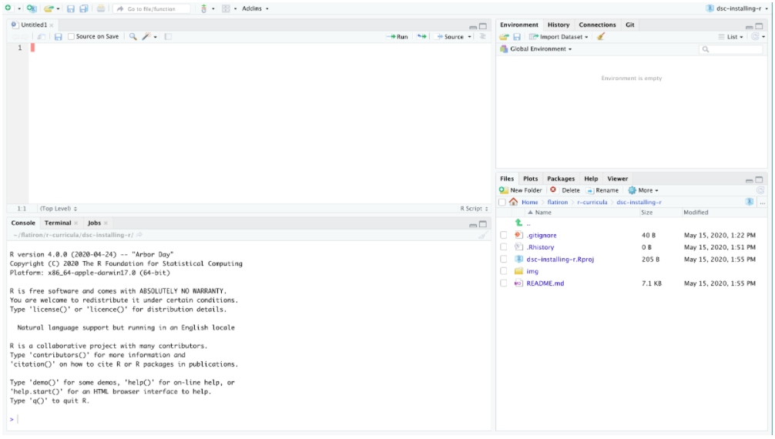

On the top left is your script editor where you write your code, on the bottom left you have your console where your code gets run. On the top right you see the environment-- something we’ll talk about soon-- and then on the bottom right we see our Viewer. You can change the positions of this if you’d like and [can find instructions to do that here](https://support.rstudio.com/hc/en-us/articles/200549016-Customizing-RStudio) and can also change the color schemes of your editor if you navigate to the preferences.

Let’s first try that!

I’d like you to go in the top toolbar then select File > Preferences ... Windows: Tools>>Global Options…

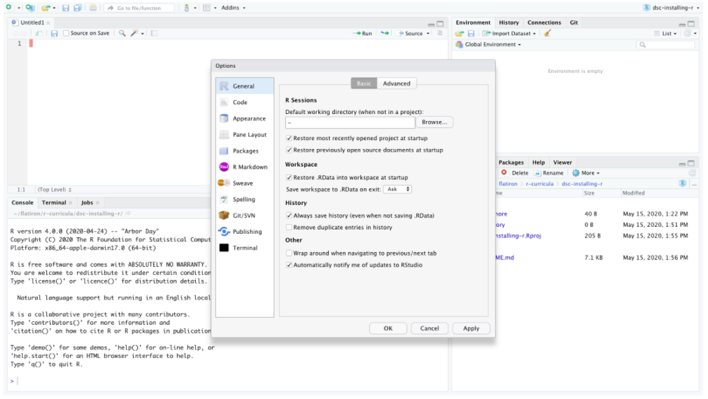

We can change here to Solarized Dark.

Now while we’re here in Preferences, let’s also do something that’s going to save you a lot of pain in the long run which is make the default behavior to never save your work space.

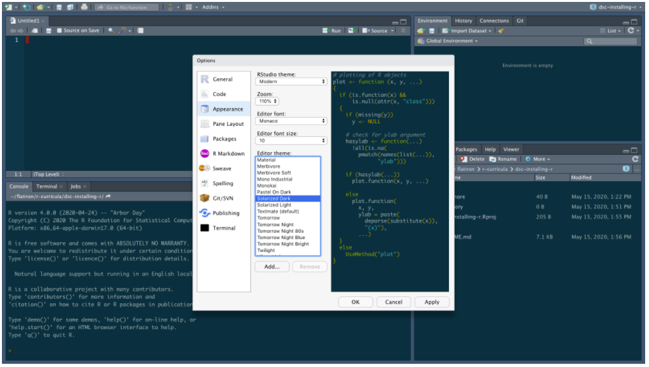

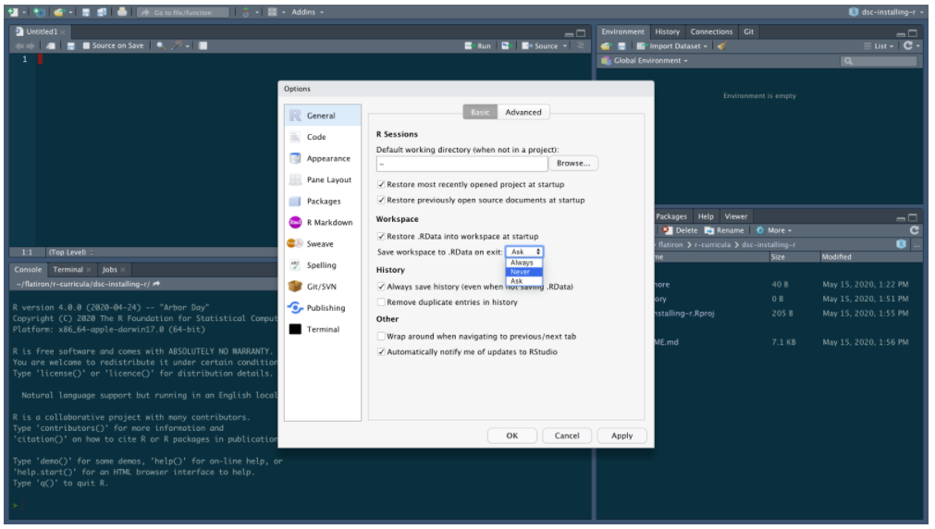

**Running a Script**

Now we’ve done a lot here to get both R and RStudio installed and set up here, let’s end with running one script!

The .rproj file basically walls off the rest of your computer so RStudio thinks the entire universe of your project lives within this area. Using .rproj files helps eliminate absolute paths and makes it so it’s a lot easier to get your R code to run on others computers. If you’re serious about learning about good practices in working with [R and RStudio, please check out this e-book here (written in R)](https://rstats.wtf/index.html).

In this local repository for this lesson, you’ll find a file called tips_report.Rmd that you should be able to see if you click the File tab on the bottom right quadrant of RStudio. This will open up your first RMarkdown file (the Juypter notebook of R).

This file contains the data and narrative we will be using the next lessons. We’ll describe it more at the start of the next lesson!

With this open, let’s just click where it says Knit at the top to see what happens.

Note here that because you’ve done a fresh install of R, you might be prompted to install a lot of software.

**Make sure you agree to all of this!**

The first time you run this, you will also see something like this which asks you if you want to install the library (or suite of libraries we’re going to use) this time. Make sure to also install this and say Yes when it asks you at the command prompt to install everything!

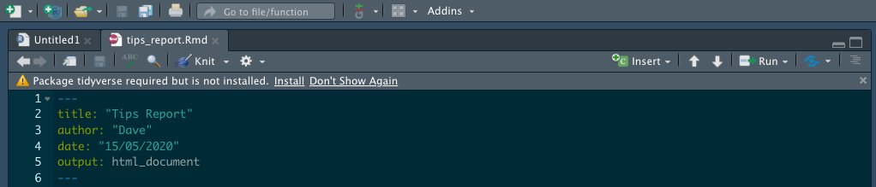

Typically we would do this at the command line with something like:

install.packages("tidyverse")

But RStudio is smart and realizes that we don’t have it and we wanted to show you that!

**DOES NOT HAPPEN AND ERRORS OUT!!!!**

Once all that software is installed, you should be able to run your script.

This will run the RMarkdown script and create a little report for you. Notice it’s an HTML file of your analysis meaning you can now just put the file.html that was just created on any website! RMarkdown allows data scientists to make quick reports in HTML, LaTeX, or even Word formats.

#### Getting Comfortable

Let’s start typing some R code! In order to get practice working in RStudio, we suggest typing out this code in the RStudio script editor (the top left panel in RStudio).

In order to make a new script you need to click the little green icon in the top left corner and select NEW SCRIPT. (New R Script)

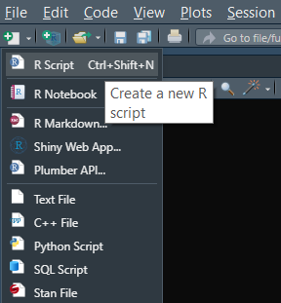

What is great about RStudio is that you can run any line of your script, just like you can run any cell in a Jupyter Notebook, individually. If you hold down CMD and press RETURN on any selected line in the editor, you can run a line. We’ll try this together.

#### First Commands

Like before, let’s try to type in some basic math into R. Instead of just typing it into the Console, let’s instead write out a line in a new script.

Again, let’s just add two numbers.

2 + 2

We can run this line by typing Ctrl + Enter assuming that the cursor is on the line you want to run. This will send this line of output to be run through the console. Notice that your output is now shown below.

Not that impressive, most programming languages can do that! Let’s now write something that actually looks like R.

my_number <- 2 + 2

Let’s now run this code here that saves our operation into an object. Now don’t just run it right away, let’s take a second to think about what is the same and different as Python. As with Python, we are assigning some sort of expression to an object. The naming conventions of objects in R as pretty much the same as Python, but notice that in R we use the assignment operator <- as opposed to equals =. There are a couple of different reasons why this is. The short answer as to why this is, is because this is part of R’s [style guide](http://adv-r.had.co.nz/Style.html). You can google around if you want to find the long answer for why this is the case.

Now as we run this line, we know from before that it will get sent to the console. So knowing that we know what will happen, let’s instead direct our attention to the top right panel when we run this. This top right panel is our Global Environment and keeps track of what variables are in our work space.

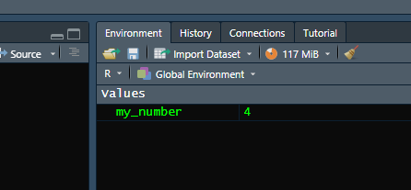 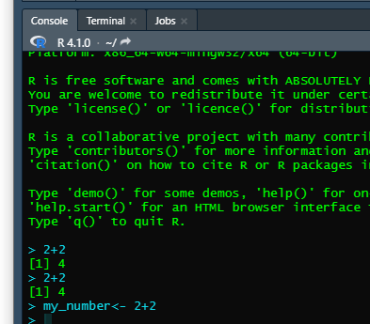

f you did this, you screen will look something like above. The command was sent below and we now have a new value in our Global environment.

Just like in Python, we can now manipulate this new object. For example if we did:

my_number * 2

Our number, 4, would get multiplied by 2 just like in Python!

But we know now that in data science, we don’t usually want to multiply just ONE number, but rather a whole collection of numbers. This is where R’s differences start to show.

Let’s now make a vector (what R calls a one dimensional collection of objects of the same type) of a some numbers using R’s c() function. We can pretend this is a bunch of data on the number of coffees you might drink in a day.

coffees <- c(2,1,2,3,1,2,0,2,3,1)

Now if we were in Python, this might start out a as a list and we’d have to numpyifiy it in order to do some math operations on it. Since R is a programming language that really is designed for manipulating numbers, we don’t have to do something equivalent.

Let’s imagine we’re trying to calculate how much caffeine we’ve taken in each day and realized that mug we’re drinking out of is actually a little big bigger than the normal cup so we need to scale our entire data by a factor of 1.2. We can just multiply the whole object by 1.2.

coffees * 1.2

If you run this, you’ll notice that it ran just fine. No need to turn a list into a numpy array.

This works because R uses element-wise execution. If you want to read more about this, check out this chapter on [The Very Basics of R](https://rstudio-education.github.io/hopr/basics.html#objects) by Garrett Grolemund. There’s a lot of other strange (if you’re a Pythonista) results that happen when you have this as a basic feature of the language.

Let’s save our new output into a new variable.

adjusted_coffees <- coffees * 1.2

Now it might seems a bit extra to have two objects of two things that are related not as part of the same entity. Since they are two vectors of the same length, we can combine them into a data frame. In order to do this, let’s make a new object with the data.frame() function.

coffee_data <- data.frame(coffees, adjusted_coffees)

coffee_data

If we now run coffee_data in RStudio, we can see something that looks like what we’re more familiar with.

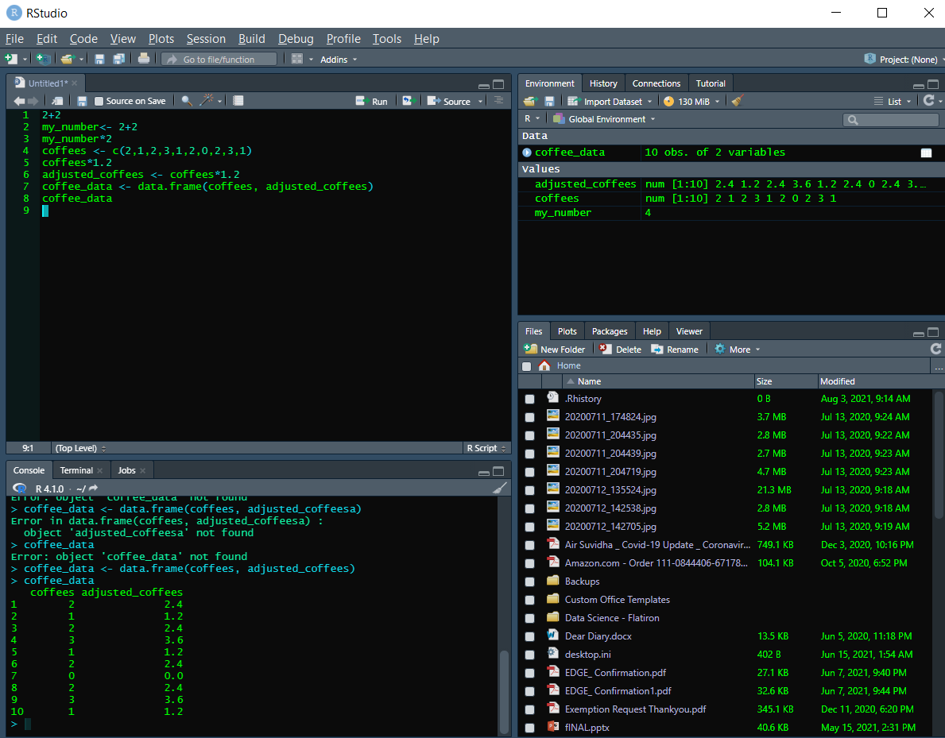

#### Accessing Data

At this point coffee_data should look pretty familiar as the kind of tabular data you’re used to working with. So how do you then subset/index parts of coffee_data? There are a couple of ways to do this with base R, but in the next few lessons, we’ll explore a way of doing this that is a bit easier to read.

The way to get subsets of data from an R object is with the square bracket operators. When using the square brackets [ and ], the first argument will correspond to rows and the second to columns. For example, if we wanted to get the first row from our coffee data we would index our data by typing:

coffee_data[1,]

After months of Python, this might be a bit jarring to see. Yes, R is 1 as opposed to 0 index. If you want the first element of an ordered object in R you use the number 1.

Notice here that there is a comma that lets R know that we’re operating on a two dimensional object (it has rows and columns). Also notice that since we want all other columns, we leave everything after the comma blank.

If we instead wanted just the first column, we would type:

coffee_data[,1]



And if we wanted the data from the first row and first column, we would type:

coffee_data[1,1]



There are other ways to get data out of a data frame and the last thing we’ll show you is one way to extract a column from a data frame. If you want to, for example, grab out the column coffees, we can use the $ to do this.

coffee_data$coffees



This will print out our original data from before. And if we wanted to get just the first entry of this, we could again use the [ ], but since we have only one dimension here, we don’t need the comma ,.

coffee_data$coffees[1]

Just like Python, there are many, many ways to expand this out to get the data you might want and you can read about it [here if you would like](https://rstudio-education.github.io/hopr/), but in the later R lessons, we’re actually going to focus on a different way of working with R to chop up data.